H**urricane Preparedness Checklists**

Time spent preparing your research area(s) and employees for a potential disaster is an essential role of the Principal Investigator (PI). Safeguarding your life’s work, personnel, and laboratories is vital for your continued research. These checklists have been developed to ensure that you, your employees and your work area(s) are suitably prepared in the event of a hurricane. Hurricane Season is from June 1 – November 30. These checklists describe actions you can take before, during, and after a storm.

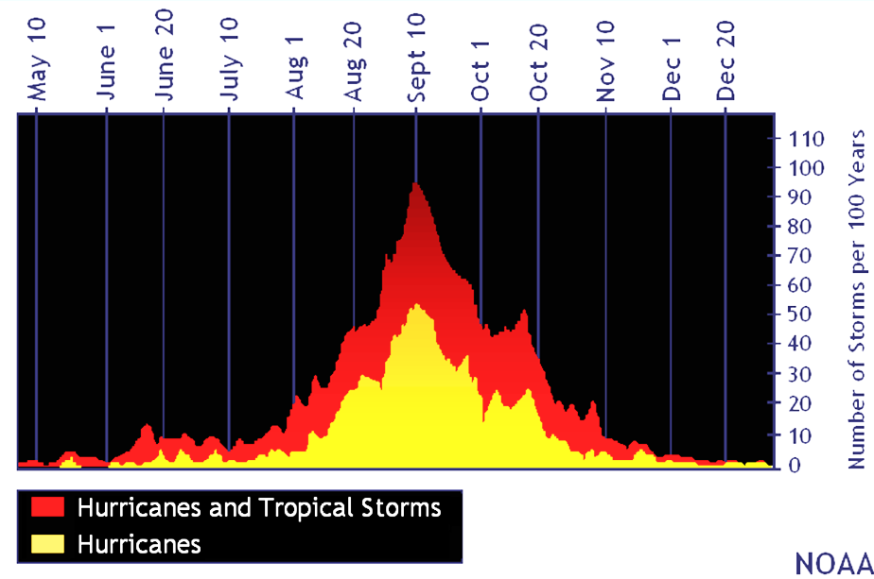

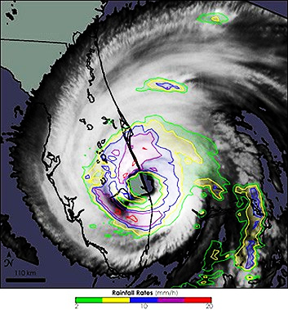

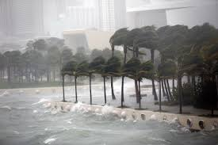

PI Name:

Location (Building(s)):

Lab/Room #(s):

# Table of Contents

Table of Contents 2

Prior to Hurricane Season 4

1.0 PREPARING SAMPLES & LAB EQUIPMENT 5

2.0 PREPARING LABS/OFFICES 6

3.0 PREPARING ADMINISTRATION/PERSONNEL 7

When a Storm is Imminent 9

1.0 PREPARING LAB/OFFICE 11

2.0 PREPARING ADMINISTRATION/PERSONNEL 12

3.0 REMAINING ON CAMPUS DURING A STORM 12

Post Disaster 13

1.0 BEFORE YOU RETURN TO WORK 13

2.0 RETURNING TO WORK 13

Appendix A: Inventory Sheet Template 14

Appendix B: Emergency Phone Tree 16

##### Useful Information and Websites

Personal Preparedness for Hurricanes

<https://prepare.miami.edu/before-emergency/hurricane-preparedness/personal-preparedness-for-hurricanes/index.html>

Environmental Health and Safety (EHS)

<https://business-services.miami.edu/departments/ehs/laboratory-safety/index.html>

Division of Veterinary Resources

<http://uresearch.miami.edu/research-resources/dvr>

UReady Continuity Planning

<https://prepare.miami.edu/before-emergency/uready/index.html>

National Hurricane Center

<https://www.nhc.noaa.gov/>

UM Emergency Management Facebook

[facebook.com/UMiamiENN](https://www.facebook.com/UMiamiENN/)

UM Emergency Management Twitter

[twitter.com/UMiamiENN](https://twitter.com/UMiamiENN)

EMERGENCY INFORMATION NUMBERS

|  |  |  |
| --- | --- | --- |
| Campus | UM Police / Public Safety / RSMAS Campus Safety  Emergency | UM Police / Public Safety / RSMAS Campus Safety  Non-Emergency |
| Coral Gables | 911 | 305-284-6666 |
| Medical | 911 | 305-243-7233 |
| Marine (RSMAS) | 911 | 305-710-7991 |
| **UNIVERSITY EMERGENCY INFORMATION HOTLINE – 800-227-0354** | | |

The latest updates on what is occurring will be posted on the University of Miami homepage, Emergency Information Hotline, and Emergency Management Social Media Accounts.

During an emergency, we recommend all employees consult the Emergency Management Social Media and the Emergency Information Hotline for updates and other important information.

# Prior to Hurricane Season

This checklist provides guidance on preparing for a potential impact from a tropical storm or hurricane. As we are unable to predict when a disaster may strike, each PI should complete this checklist annually prior to Hurricane Season. Although this checklist focuses on your employees, the preparation of your work area(s), and lab equipment prior to Hurricane Season, the steps you will have carried out upon completion of this document will better prepare you for any other potential disasters.

Detailed information about how to accomplish items on the checklists is on the following pages.

|  |  |
| --- | --- |
| 1.1 | Register and label critical equipment (Medical School Only). |
| 1.2 | Inventory each freezer/refrigerator/cryogenic tank/cold room. |
| 1.3 | Identify critical samples. |
| 1.4 | Division of Veterinary Resources (DVR) information |

### PREPARING SAMPLES & LAB EQUIPMENT

### PREPARING LAB/OFFICE

|  |  |
| --- | --- |
| 2.1 | Update emergency supply inventory. |
| 2.2 | Keep full liquid nitrogen supply tanks and compressed gas (ex. CO2, N2,) cylinders on hand. |
| 2.3 | Radioactive waste preparation |
| 2.4 | Confirm that your spill control kit is stocked and its location is marked. |
| 2.5 | Confirm data storage |
| 2.6 | Take photos/videos of office area, lab area, and all equipment. |
| 2.7 | Update lab signage. |
| 2.8 | Check your fire extinguisher. |
| 2.9 | Don’t stack supplies up to the ceiling. |
| 2.10 | Observe good housekeeping. |
| 2.11 | Check chemical containers for integrity. |
| 2.12 | Keep chemicals below shoulder height. |
| 2.13 | Properly secure gas cylinders. |
| 2.14 | Segregate chemicals by hazard class. |
| 2.15 | Use secondary containment for chemicals and liquid waste. |
|  |  |

### PREPARING ADMINISTRATION/PERSONNEL

|  |  |
| --- | --- |
| 3.1 | Review/maintain individual unit plan via UReady. |
| 3.2 | Update emergency contact information in Workday. |
| 3.3 | Designation of Emergency Workforce Personnel |
| 3.4 | Designate an alternate contact in case of your absence. |
| 3.5 | Develop/maintain an emergency lab/office personnel contact list/phone tree. |

### PREPARING SAMPLES & LAB EQUIPMENT PRIOR TO HURRICANE SEASON

#### Register and label critical equipment (Medical Campus Only)

* + - Applicable to critical equipment that is valued at greater than $2,499 or necessary for the laboratory’s function (e.g., -80 freezers).
    - Ensure that all critical equipment has been registered with Miller School Public Safety and labeled accordingly.
      * Visit the link listed below and complete the information to inventory critical equipment such as freezers, refrigerators, and incubators in case of a loss of power (<http://publicsafety.med.miami.edu/critical-equipment-registration>).
        + Upon registering, a four-digit Critical Equipment Registration Form (CERF) number will be provided for identification of your unit.
        + Print and post your CERF on your critical equipment, which includes all emergency contact information and equipment normal operating values (temperature, % of CO2, etc).
    - Check your critical equipment alarm.
      * For refrigeration units connected to Public Safety’s ProWatch monitoring system:
        + The alarm circuit is usually tested during initial installation. To ensure that the alarm system is fully active, a lab contact should trigger the alarm.
        + Contact Public Safety (305-243-6000, 305-243-7233) to confirm this is a “test” and for the dispatcher to verify that they have received systematic notification of the alarm.
        + If you require assistance testing your alarm contact the Public Safety Systems Supervisor at 305-243-8375.
      * For refrigeration units connected to other monitoring systems, run regular tests by placing your unit in alarm to confirm the system is contacting you, then place back to normal.

Below is an image of an alarm being tested.

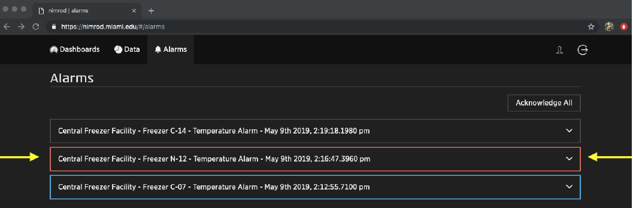

#### Inventory each freezer/refrigerator/cryogenic tank/cold room

* + - Inventory and document all product/sample information, including serial/order numbers, location, quantity, and value. The value of such items is required for insurance and FEMA-related claims in the event of storm-related loss or damage. Sample inventory templates are attached in Appendix A.
    - Ensure that the inventory information for your freezer/refrigerator/LN2 tank/cold room is current and reflects the content of the freezer and the owner of the material.

#### Identify critical samples.

* + - Please identify (label) those samples that are most critical for your work/mission.
    - In the case of a pending hurricane, power outage, etc., it may be necessary to move or relocate your samples.
    - Consider sending critical or irreplaceable samples out of the area through pre-existing arrangements with a University-approved professional bio-repository and/or non-local collaborators/colleagues.

#### Division of Veterinary Resources (DVR) Information

* + - For animal study resources, visit

<http://uresearch.miami.edu/research-resources/dvr>

* + - No DVR animals or animal records should be removed from campus by a Principle Investigator at any time.

### PREPARING LABS/OFFICES PRIOR TO HURRICANE SEASON

#### Update emergency supply inventory

* + - Supplies on hand should include plastic sheeting and tape to cover computers, non-critical lab equipment, desks, etc., and materials to protect the facility, contents, and for post-disaster cleanup. No equipment should be covered while plugged in.
    - Some suggested Hurricane Supplies may be purchased through the Grainger Catalogue in the Workday Market Place.
      * Plastic storage box (52VN75)
      * General Purpose LED Flashlight (32ZN12)
      * “D” Batteries (5LE21)
      * Plastic sheeting, 2 mil/10ft x 100ft (15J255)
      * Plastic sheeting, 3 mil/10ft x 100ft (15J256)
      * Clear carton sealing tape (31HJ46)
      * Jumbo plastic bags (#65645)
      * Large tarp
      * Bungee cords (4HXF7)
      * LCD Refrigerator/Freezer Thermometer (8RFZ6)
      * Sheet Protectors, Clear (1PRR2)
      * Portable Weather Radio, AM/FM, NOAA (22A871)
    - Some supplies, mostly plastic sheeting and duct tape, are available in limited quantities on a first-come-first-serve basis from the Physical Plant Stock Room, which is located in the basement of the Rosenstiel Medical Research Building. Below is an example image of supplies to prepare your work area.

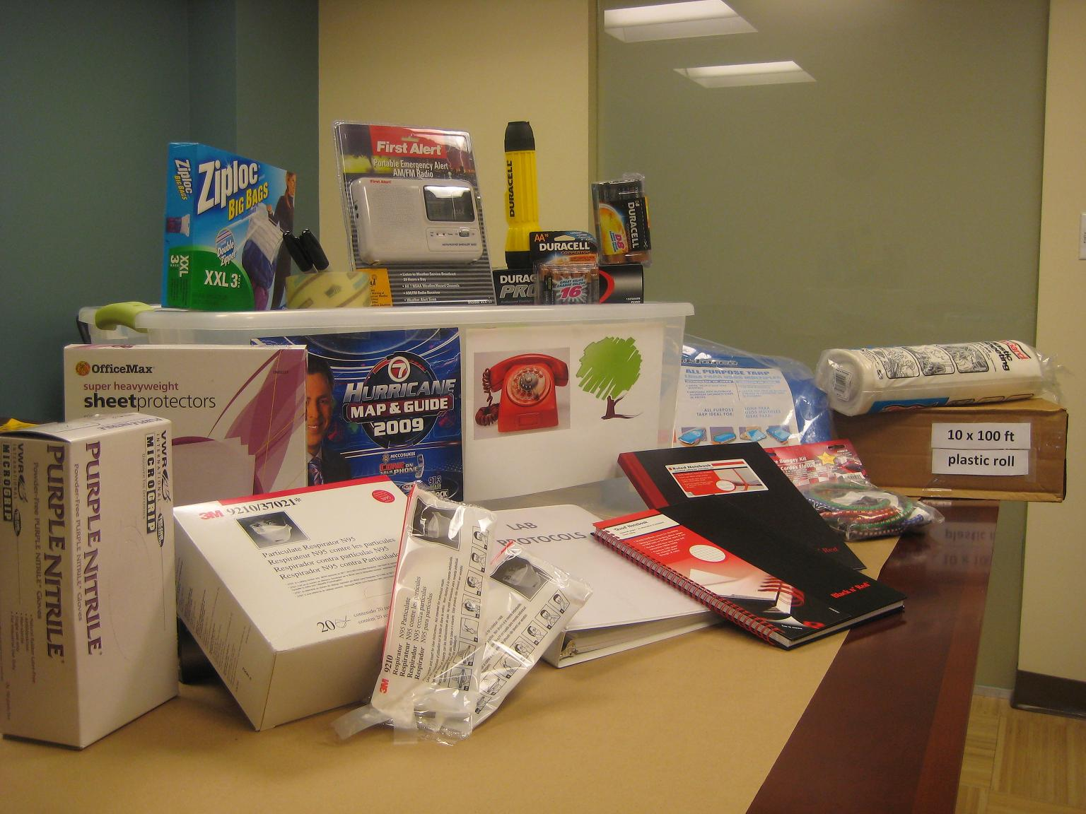

#### Keep full liquid nitrogen supply tanks and gas (CO2, N2) cylinders on hand

* + - Our gas suppliers are expected to stop delivery 24 hours before anticipated arrival of tropical storm force winds.

#### Radioactive Waste

* + - Minimize waste stored in your lab.
    - Make sure all radioactive waste is properly packaged and secured.
    - Minimize the amount of stock material held in the lab and review storage and security of that material.
    - Discuss any issues or concerns regarding radioactive waste with Radiation Control at 305-243-6360.

#### Confirm that your spill control kit is stocked and its location marked

* + - Have spill clean-up materials that are appropriate for the hazards in the lab.
      * Chemical spill kit guidance can be found at

<https://business-services.miami.edu/_assets/pdf/Chemical%20Spill%20kit.pdf>

* + - * Biological spill kit guidance can be found at

<https://business-services.miami.edu/_assets/pdf/Bio%20Spill%20Kit.pdf>

#### Data Storage

* Never store data on your computer’s hard drive. Use approved cloud-based storage systems (Box, Microsoft OneDrive, Google Drive, etc.).
* Create digital versions of paper documentation in PDF format
* Check the data integrity of stored data files at regular intervals
* Ensure HIPPA compliance when the type of research requires it.
* Document grant information including study, agency, and award number.

#### Take photos/videos of office area, lab area, and all equipment

* Photo document all research lab equipment and office furniture. Guidelines are available at

<http://publicsafety.med.miami.edu/documents/Photo_Documentation.pdf>

#### Update lab signage

* Post signage indicating the hazards present, such as biohazard and/or radiation signage.
* Emergency contact signage should up to date, accurate, and displayed at the lab entrance listing responsible persons knowledgeable of the contents in the lab.
* New signage can be provided by EHS upon request.

#### Check your fire extinguisher

* Ensure that your nearest extinguisher is present and the tag has been signed by the inspector.

#### Don’t stack supplies up to the ceiling

* + - Remove items within 18” of the ceiling to allow for safe function of building sprinkler systems.
  1. **Observe good housekeeping**
* Unnecessary clutter/obstructions on floors or surfaces must be removed.
* Biological labs need to be disinfected per established schedule.

#### Check chemical containers for integrity

* Chemical containers should be in good condition.

#### Keep chemicals below shoulder height

* To prevent spills or falling containers, chemicals and other hazardous liquids stored should not be stored above shoulder height.

#### Properly secure compressed gas cylinders

* Gas cylinders are secured between the middle and shoulder of cylinder.
* Limit the number of cylinders attached on any one restraint.

#### Segregate chemicals by hazard class

* Chemicals are segregated by hazards.

#### Use secondary containment for chemicals and liquid waste

* Secondary containment is required for liquid hazards to prevent spills.

### PREPARING ADMINISTRATION / PERSONNEL PRIOR TO HURRICANE SEASON

#### Review/maintain individual unit plan via UReady

[www.miami.edu/uready](http://www.miami.edu/uready)

* Distribute the unit plan to all personnel, and periodically review its contents.

#### Update emergency contact information in Workday

* Emergency Contact and Evacuation Information is maintained in Workday. Ensure your information is up-to-date and accurate.
  + If, for whatever reason, your location changes, please update the system as soon as physically possible. Guidance on how to do so can be found [here](https://prepare.miami.edu/_assets/pdf/ESS_PersonalInformation_ChangeContactInformationIncludingMailingAddress.pdf).

#### University Declared Emergency, Employee Responsibilities, and Compensation

* Guidelines for identification of employees who are and/or may be required to provide critical services during a declared emergency and pay during a declared emergency can be found [here](https://umiami.policystat.com/policy/5857297/latest/).
* The [Designating Personnel Tip Sheet](https://my.it.miami.edu/wda/erpsec/tipsheets/MSS_HR_DesignatingEssentialPersonnel.pdf) provides detailed instructions on how supervisors update an employee's tier designation. Supervisors shall also explain to employees what potential role(s) they will have during an emergency.

#### Designate an alternate contact in case of your absence

#### Develop/maintain an emergency lab/office personnel contact list / phone tree

* The Contact List ensures all employees are safe and receive up-to-date information in the event of a hurricane.
  + Include detailed instructions on the use of the phone tree and the responsibilities of the individuals listed within the tree.
    - Include the following information for each employee: Name, Office, Home, and Cellular Phone numbers, E-mail Address.
    - The primary contact (employee at the top of the tree), initiates the sequence.
    - In-turn, each employee calls the next contact in line relaying the information they receive from the prior employee.
    - In the event the assigned contact does not answer, the employee must leave a message advising the contact to call the “primary contact” and then call the next employee in the sequence.
    - When the subsequent contact is called, the employee must advise they were unable to contact the previous employee on the tree and confirm they relay this information to the next in the sequence until the end of the loop.
    - The last employee to be contact should contact the primary contact and inform them of who was not able to be reached.
    - The primary contact is responsible to ensure all their assigned employees are contacted.
* See Appendix B for a sample phone tree.

# 

# When a Storm is Imminent

Once you have completed the“Prior to Hurricane Season” checklist,you will be in a better position to respond “When a Storm is Imminent”. As we are unable to predict when a disaster may strike, we have compiled the next step checklist, being mindful of what to do in the event of an approaching storm. Many, if not all, of the points contained within this document would be relevant for other disaster situations. It is recommended that these activities commence no later than 72 hours prior to the anticipated arrival of tropical storm force winds.

Detailed information about how to accomplish items on the checklists is on the following pages.

### PREPARING LAB/OFFICE

|  |  |
| --- | --- |
| 1.1 | General Operations |
| 1.2 | Turn off and unplug all equipment that does not require emergency power (including computers). |
| 1.3 | Prepare labs and offices with windows |
| 1.4 | Chemicals and glassware |
| 1.5 | Biohazardous waste |
| 1.6 | Radioactive materials and waste |
| 1.7 | Send critical samples for off-site storage. |
| 1.8 | Transfer critical samples to freezers, refrigerators, and cold rooms that are connected to emergency power. |
| 1.9 | Top off liquid nitrogen cryogenic storage tanks for submerged vials. |
| 1.10 | Replace gas (carbon dioxide, nitrogen, etc) cylinders with full tanks. |
| 1.11 | Prepare animals that require special care beyond established husbandry practice. |
| 1.12 | Conduct final walkthrough before leaving. |
| 1.13 | Clear hazardous materials from benchtops and equipment. |
| 1.14 | Close and lock doors when leaving. |
| 1.15 | Leave the lab organized. |

### PREPARING ADMINISTRATION/PERSONNEL

|  |  |
| --- | --- |
| 2.1 | Distribute emergency phone tree to all lab/office members. |
| 2.2 | Confirm emergency contact information is correct in Workday. |
| 2.3 | Safeguard all critical files and photographic documentation. |
| 2.4 | Protect non-critical equipment. |
| 2.5 | Secure valuable information. |
| 2.6 | Relocate equipment from flood prone areas. |

### REMAINING ON CAMPUS DURING A STORM

|  |  |
| --- | --- |
| 3.1 | Confirm preapproved designated emergency workforce personnel are available and ready. |

### PREPARING LAB/OFFICE WHEN A STORM IS IMMINENT

#### General Preparations

* Remove any food and perishable supplies from your office
* Completely clean all laboratory benches (where practical)
* Lock all file cabinets, desk drawers and office/lab doors

#### Turn off and unplug all equipment that does not require emergency power (including computers)

* Refrigerators and freezers should be left ON at the coldest setting that will not cause damage to the contents. To ensure a better seal, you may consider taping the door closed.
* Equipment that is running and requires ventilation should be NOT BE covered (ex. refrigeration, incubators, etc.)

#### Preparation of labs and offices with windows

* Clear desk/table tops of books, files, papers, etc. and place them inside desks, drawers, cabinets etc.
* Remove all items from window ledges and verify that all windows are closed and sealed.
* If practical, move desks, file cabinets and equipment away from the windows and off the floor.
* Store as much equipment as possible in closets or windowless rooms.
* Cover desks, drawers, cabinets etc. with plastic sheeting and tape securely. Do not cover any equipment that is still energized.

#### Chemicals and glassware

* Remove bottles & chemicals from shelves and place in cabinets, or on the backs of benches against wall.
  + Refer to

<https://ehs.miami.edu/services/laboratory-safety/hurricane-preparedness/index.html>

* Due to the possibility of power outages, volatile, toxic materials as well as those that may cause respiratory hazards should not be stored in fume hoods or refrigerators, but in tightly sealed, impervious and break-resistant containers.
* All hazardous materials should be secured in cabinets or moved to inside labs.
* Chemicals should be segregated based on their compatibility.

#### Biohazardous Waste

* Secure all biohazardous waste and take to designated biohazard bins.

#### Radioactive Materials and Waste

* Secure all radioactivity stocks.
* Call the Radiation Control Center (305-243-6360) to organize a pre-storm pick-up of any radioactive waste.
  + Radiation Control will continue operations and pick up waste on the Medical Campus as time permits while the campus is open.
  + Waste from other campuses will not be picked up once a Tropical Storm Watch is issued for Miami-Dade County.

#### Send critical samples for off-site storage

#### Transfer critical samples to freezers, refrigerators and cold rooms that are connected to emergency power

* Do not use an extension cord to connect to emergency power (red outlets). This may overload the system!

#### Top off liquid nitrogen cryogenic storage tanks for submerged vials

#### Replace gas (carbon dioxide, nitrogen, etc.) cylinders with full tanks

#### Prepare animals that require special care beyond established husbandry practice

* Contact a DVR veterinarian for prearranged special care.

#### Conduct final walk-thru before leaving

* Ensure all items are secured, cabinets and doors are locked, and that all preparations have been completed.

#### Clear hazardous materials from benchtops and equipment

* Biosafety cabinets, fume hoods, and other equipment must be cleared of hazardous materials.

#### Close and lock doors when leaving

* Doors to the lab should be closed and locked to prevent unauthorized access.

#### Leave the lab organized

### Unnecessary clutter/obstructions on floors or surfaces should be removed.PREPARING ADMINISTRATION/PERSONNEL WHEN A STORM IS IMMINENT

#### Issue paper copy of emergency phone tree to all lab/office members

* + - Reference the “Prior to Hurricane” checklist for guidelines.

#### Confirm emergency contact information is correct in Workday

* + - Ensure that your information is up-to-date and accurate. If, for whatever reason, your location changes, please update the system as soon as possible.

#### Safeguard all critical files and photographic documentation

* + - If you have not already done so, back up data from your hard drive to your shared drive or cloud-based storage.
    - Ensure you have all photo documentation of the lab, including a high angle view and close-ups of individual equipment.

#### Protect non-critical equipment

* + - Turn off, unplug, and elevate.
    - Cover with plastic sheeting and secure with clear sealing or duct tape.

#### Secure valuable information

* Place the following items in plastic bags.
  + Lab notebooks
  + Books
  + Valuable papers
  + Protocols in progress
  + Sources of data
  + Proposals
  + Workday program name of project for active awards
  + Recent budget account statements
  + Agency program contact information

#### Relocate lightweight equipment from flood prone areas

* + - In locations where flooding is a possibility, to the extent practical, relocate critical equipment from the ground floor to a higher floor or a higher off-site location.

### REMAINING ON CAMPUS DURING A STORM

#### Confirm designated emergency workforce personnel are available and ready

Once you have been officially notified that the University of Miami Miller School of Medicine will close, you will not be allowed access to the research facilities until the buildings are assessed by Public Safety and Facilities & Operations and deemed safe for reentry.

For more information about continuing critical services during an emergency, such as a hurricane, please refer to the [University Declared Emergency, Employee Responsibilities, and Compensation Policy](https://umiami.policystat.com/policy/5857297/latest/).

# Post Disaster

This checklist focuses on the activities that must be carried out before and after you and your employees return to work. The University is committed to restoring research activities as soon as is safely possible. After Facilities & Operations and Public Safety deem the buildings safe, Public Safety will return each building to “weekend access” status for magnetic card entry. As each building is cleared, information is posted to the website and social media and relayed via **EMERGENCY INFORMATION HOTLINE 1-800-227-0354.** The time required to re-open depends upon the severity of the storm.

### BEFORE YOU RETURN TO WORK

|  |  |
| --- | --- |
| 1.1 | Contact UM Emergency Information Hotline with questions not answered through mass communication. |
| 1.2 | Contact your immediate supervisor. |
| 1.3 | Initiate Phone Tree. |

### RETURNING TO WORK

Depending on the severity of impacts, the following items should be considered as you work to reconstitute regular research operations within your lab.

|  |  |
| --- | --- |
| 2.1 | Implement your UReady Business Continuity Plan. |
| 2.2 | Conduct a damage assessment of your work area, take pictures of all damaged equipment, and complete the [Damaged Inventory Worksheet](https://business-services.miami.edu/departments/risk-management/forms/damaged_inventory_worksheet.pdf). |
| 2.3 | Implement steps to minimize any further loss as a result of impacts sustained. |
| 2.4 | Report impacts to your work area(s) to your supervisor or department head. |
| 2.5 | Do not discard damaged capital equipment until Risk Management has been notified. |
| 2.6 | Contact your supervisor or department head if you cannot continue working and when you expect to resume work. |
| 2.7 | Complete a Risk Management Claims Worksheet. |
| 2.8 | Contact your Grants Program Administrator and University of Miami Office of Research Administration (ORA). |
| 2.9 | Relocate your lab activities until workspace can be repaired or replaced. |
| 2.10 | Retrieve your critical samples. |
| 2.11 | Verify storage equipment is working and equipment is functional. |

## Appendix A: Inventory Sheet Template

INVENTORY SHEET TEMPLATE

(Freezer/Refrigerator/Cold Room/LN2)

|  |  |  |
| --- | --- | --- |
| Lab: | | |
| Inventory: | | |
| Location: | | Serial/ID #: |
| Emergency Contact 1: | | Contact #: |
| Emergency Contact 2: | | Contact #: |
|  | | |
| Shelf #­­­___ |  | |
| Shelf #­­­___ |  | |
| Shelf #­­­___ |  | |
| Shelf #­­­___ |  | |
| Shelf #­­­___ |  | |
| Shelf #­­­___ |  | |
| Shelf #­­­___ |  | |
| Shelf #­­­___ |  | |
| Shelf #­­­___ |  | |
| Shelf #­­­___ |  | |
| Shelf #­­­___ |  | |
| Shelf #­­­___ |  | |
| Shelf #­­­___ |  | |
| Shelf #­­­___ |  | |
| Shelf #­­­___ |  | |
| Shelf #­­­___ |  | |

INVENTORY SHEET TEMPLATE

|  |  |  |
| --- | --- | --- |
| Lab: | | |
| Inventory: | | |
| Location: | | Serial/ID #: |
| Emergency Contact 1: | | Contact #: |
| Emergency Contact 2: | | Contact #: |
|  | | |
| Box #___ | Samples: | |
| Number of Tubes: | |
| Label: | |
| Misc.: | |
| Box #___ | Samples: | |
| Number of Tubes: | |
| Label: | |
| Misc.: | |
| Box#___ | Samples: | |
| Number of Tubes: | |
| Label: | |
| Misc.: | |
| Box#___ | Samples: | |
| Number of Tubes: | |
| Label: | |
| Misc.: | |
| Box#___ | Samples: | |
| Number of Tubes: | |
| Label: | |
| Misc.: | |

## Appendix B: Emergency Phone Tree

Primary Contact:



The last person to be contacted should contact the Primary Contact and inform them of who was not able to be reached.